**HOW TO**

This is an archive with blockchain folders for quick synchronization.

In square brackets you will see the date of creation of the archive.

You need to close the wallet and from the folder %appdata%\XVIC delete the folders of the same name, which are in the archive.

Then unzip the folders from the archive to the %appdata%\XVIC folder and start the wallet.

Tools:

[**7-Zip**](https://www.7-zip.org/) is a file archiver.

1. Wait for the wallet to complete.

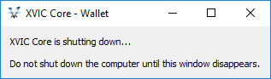

1. Open any folder. In the address bar, type %appdata%\XVIC and press ENTER.



1. Select the files as in the screenshot and press the DELETE key. Confirm that you want to delete the folders.

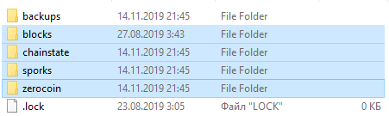

*to be continued on the next page*

1. Download the archive.

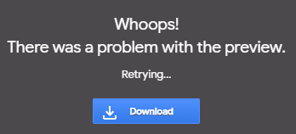

1. Open archive. Select all files inside the archive. And drag these files with the mouse to the desired folder. ( %appdata%\XVIC )

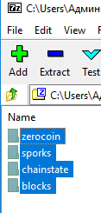

1. Wait for the copy to finish.
2. Open your wallet.